Original Paper

P athobiology 2016;83:79–88 P ublished online: April 26, 2016
D OI: 10.1159/000442391

Current Status of Whole-Slide Imaging in Education
A dela Saco ª Jose Antoni Bombi ª Adriana Garcia ª Jose Ramírez ª Jaume Ordi ^{a, b}
ª D epartment of Pathology, Hospital Clínic, University of Barcelona School of Medicine, and ^{b} I SGlobal, Barcelona

Center for International Health Research (CRESIB), B arcelona, Spain

Key Words
M edical education · Teaching · Virtual microscopy · Whole-slide imaging

Abstract
Conventional light microscopy (CLM) has classically been the basic tool to teach histology and pathology. In recent years, whole-slide imaging (WSI), which consists of generating a high-magnification digital image of an entire histological glass slide, has emerged as a useful alternative to CLM offering a myriad of opportunities for education. Navigation through the digitized slides closely simulates viewing glass slides with a microscope and is also referred to as virtual microscopy. WSI has many advantages for education. Students feel more comfortable with its use, and it can be used in any classroom as it only requires a computer with Internet access and it allows remote access from anywhere and from any device. WSI can be used simultaneously by a large number of people, stimulating cooperation between students and improving the interaction with the teachers. It allows making marks and annotations on specific fields, which enable specific directed questions to the teacher. Finally, WSI supports are cost-effective compared with CLM. Consequently, WSI has begun to replace CLM in many institutions. WSI has shown to be an extremely useful tool for undergraduate education (medical, dental and veterinary schools), for the training of residents of pathology, tele-education and in tumor boards. © 2016 S. Karger AG, Basel

Introduction and Historical Perspective

B asic skills in histology and pathology are an essential component of the education of undergraduate students, not only at medical schools, but also at schools of dentistry, veterinary medicine and biology. Residents and fellows in pathology demand more advanced training, and certified pathologists require continuing education. This training has to be provided more and more often to participants located in distant sites. Until a few years ago, the only tool that fulfilled these needs was conventional light microscopy (CLM). CLM was introduced as a diagnostic and teaching tool nearly two centuries ago and became the basis for teaching histology and pathology [1, 2] . However, CLM has many limitations, not only in conducting the classes but also in assessing the skills of the students. One of the main disadvantages of using CLM is that it does not allow simultaneous viewing of the slides
© 2016 S. Karger AG, Basel
1015–2008/16/0833–0079$39.50/0 Department of Pathology, Hospital Clínic
University of Barcelona, C/Villarroel 170
E-Mail karger@karger.com
ES–08036 Barcelona (Spain)
www.karger.com/pat
E-Mail jordi @ clinic.ub.es
Jaume Ordi
Table 1. Major educational uses of WSI

Undergraduate teaching (medicine, veterinary medicine, biology and dentistry)
Pathology training (residency and fellowship programs)
Schools of cytotechnology
Tumor boards
Tele-education, e-learning and virtual workshops

by multiple students. Secondly, rooms with multiple microscopes are expensive and require continuous maintenance. A third important disadvantage of CLM is the need to generate glass slides and store them, which entails significant economic costs and the loss of specimen material.
In the early 20th century, the emergence of projectors facilitated the training of students because it allowed displaying the histological images to a number of participants at the same time. The introduction and development of initially analogic and later on digital video cameras boosted the use of CLM in multiple teaching settings. However, these devices allowed moving the slide only to one person and, consequently, served as a teaching supplement but did not allow the replacement of CLM.
In the 1980s, the first digital images were generated from histological slides, although it was not until later, with the advent of personal computers with sufficient memory capacity, that digital microscopy progressed rapidly to the technology we know today. A few years later, imaging converter programs and servers appeared which allowed uploading the virtual slides to the web and permitted viewing the images and zooming [1] .
Whole slide imaging (WSI), also referred to as virtual or digital pathology, consists of generating a virtual image of the entire histological glass slide. The process is performed by WSI scanners, robotic microscopes capable to automatically generate digital images from the glass slide. Current scanners are able to use different optical objectives (×10, ×20, ×40 and ×60) depending on the specific needs and allow scanning the whole slide or a particular portion of the tissue. Specific software allows viewing digital slides online from computers without the need for a CLM. At present, there are numerous systems prepared to generate good-quality virtual images of histological sections obtained from paraffin blocks or frozen tissue as well as from cytological smears. Image browsing is performed with a mouse or a joystick, which allows moving through the different areas of the slide and permits image zooming, thus simulating the optical objectives of a CLM [3] . Software viewers have multiple tools to make measurements and annotations on the images, and may contain additional patient information, thus providing a complete view of the cases [4]. The information is adequately protected because, although students and residents can access the virtual slides from any computer, access is controlled by the use of a specific password and
registration in the system.
WSI is an extremely useful teaching tool because it allows displaying the histological slides on a computer monitor and solves many of the problems of CLM. Indeed, WSI has been used for many different educational activities ( table 1 ). This technology is rapidly expanding as a teaching tool, either as a complement to or a substitute of CLM. In many centers, the transition from CLM to WSI has already occurred either gradually or suddenly. This review focuses on the applications of WSI (or virtual microscopy) in education.

Advantages of WSI
WSI has brought about an important change in the way of understanding teaching in histology and pathology, allowing the introduction of some actions and capacities that were previously not possible. The main advantages of WSI are summarized in t able 2 .
Some of the advantages of WSI are related to the change in the physical tool itself. WSI allows any computer to work as a CLM, and consequently reduces or eliminates the need for conventional microscopes. It has been clearly shown that students feel more comfortable with the use of WSI because they all have prior knowledge of computers (almost all students are currently digital natives) [5–10]. An additional advantage of WSI is that the slides are always in focus. Thus, the students get used to the tool very quickly and can immediately concentrate on the histological features of the slides and do not have to become acquainted with the microscope [6, 9, 10] . WSI can be used in any classroom, because it only requires a computer with Internet access [1, 11] . Moreover, WSI allows access from any device, either in or outside the facilities of the institution. This implies that the students can review the histological slides at any time and from anywhere, thereby facilitating their study and eliminating the restrictions of access to the laboratory of microscopy after class hours [1, 6, 10, 12–14]. As a consequence, laboratories of microscopy, which are very expensive and costly in maintenance, become unnecessary, leading to a significant reduction in costs [9,
15] . With an appropriate bandwidth, virtual microscopes can be used simultaneously by a large number of people, thereby surpassing the restrictions related to a limited number of CLMs in a laboratory [4, 9, 12, 16, 17] and stimulating cooperation between students [9, 12, 15, 17–19] . Moreover, the interaction between teachers and students is improved by viewing the same image at the same time in the classroom, which allows bringing up questions easily and improves the learning curve [15, 18, 19] .
Table 2. Advantages of WSI for teaching purposes

Related to the equipment
Students feel more comfortable with the use of the virtual microscope because they have prior computer knowledge
It can be used in any classroom: it only requires a computer with Internet access
It allows remote access anywhere and from any device
It can be simultaneously used by an unlimited number of people
Several students can use the same computer at the same time, stimulating cooperation between students
It improves the interaction between teachers and students by viewing the same image at the same time Eliminates the need for investing in the creation and maintenance of microscopic laboratories

Related to the viewer
The thumbnail in the viewer facilitates better orientation when the students browse through the slide
The information of the histological slide can be completed with macroscopic images, immunohistochemical stains, radiological images and clinical data
Several slides can be displayed simultaneously on the same screen, facilitating the interpretation of immunohistochemical techniques Marks and annotations can be made on specific fields, which facilitate specific directed questions to the teacher

Related to the digital slides
No deterioration in digital slides with time and slides do not have to be replaced
Homogeneity in the quality of images available to students
Additional histological sections are not needed
Cases with scant tissue or consultation material can also be studied
FISH or immunofluorescence digital images do not lose fluorescence
Old cases are immediately accessible, without the help of technical staff searching for the files in the archive

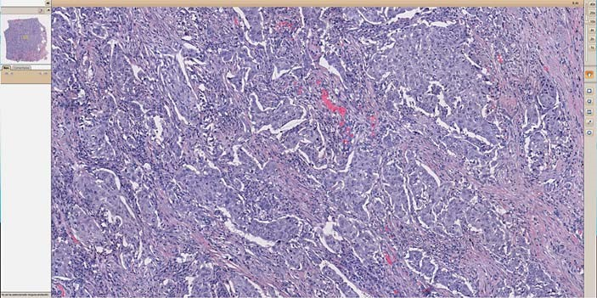Fig. 1. The viewer displays a thumbnail that indicates the area shown on the screen. This promotes better orientation when the student browses the slide.
The second group of advantages of WSI is related to the characteristics of the viewer. The presence of a thumbnail indicating the area shown on the screen (f ig. 1) promotes better orientation when the student browses the slide [12]. Digital viewers allow seeing the slide at a very low magnification, which also helps the student to be orientated in the tissue. Teaching tools based on WSI allow completing the information of the histological slides with clinical data, imaging studies (conventional radiology, CT, ultrasound and MRI), macroscopic images, as well as
Pathobiology 2016;83:79–88
DOI: 10.1159/000442391
histochemical or immunohistochemical stains (f ig. 2) , which, in turn, allow a more complete picture of the study cases [16, 17] . Many viewers allow simultaneously displaying several slides on the screen, thus facilitating the interpretation of immunohistochemical techniques by comparing them with the conventional hematoxylin-eosin stain (f ig. 3) [1]. Another feature of WSI viewers that is particularly helpful for teaching purposes is the possibility to make marks and annotations on specific fields of the digital slides to show the key features that allow the recognition of the lesions. This tool facilitates solving specific doubts and improves the interaction between the teacher and the student. With the annotations made by the teacher, the students can easily identify the key areas on a slide, allowing them to focus on the diagnostic clues of a specific lesion. Annotations and marks made by the students allow them to ask the teacher about specific doubts. Indeed, annotations seem to improve the final results of the students, and several studies have shown that the students who had notes on the slides have better scores than those who do not make any annotation [1, 12, 14, 20–22] .
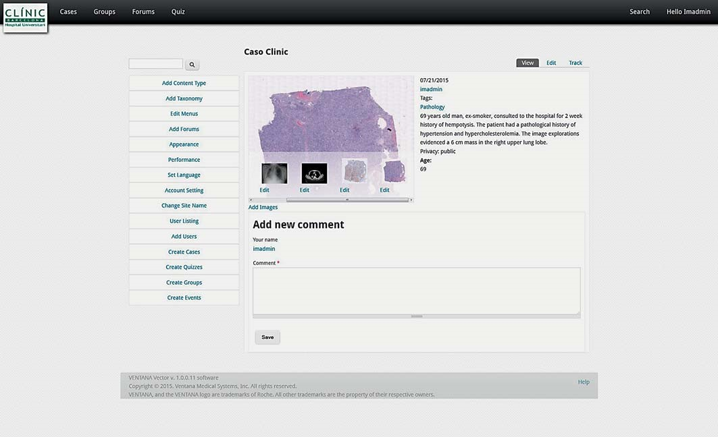
Fig. 2. Teaching tools based on WSI allow completing the information of the histological slides with clinical information, imaging studies (conventional radiology, CT, ultrasound and MRI) macroscopic images, as well as histochemical or immunohistochemical stains.
The third set of advantages of WSI is related to the histological slides. Digital slides always have the same quality. They never break, get lost or deteriorate with time. Thus, it is not necessary to replace them by recutting and staining new slides every certain period of time, with the subsequent impact on costs and preservation of the frequently highly valuable tissue from the paraffin block [17, 20] . WSI homogenizes the material available to students. All students have exactly the same digital slide, which eliminates the variability in quality among different glass slides. Creating selections of interesting cases to students becomes extremely easy because there is no need for additional histological sections [10, 17, 22] . The easiness to prepare collections of cases with a high number of slides from each organ or pathology allows randomly showing many different cases to the students. This makes the student learn to recognize the histological characteristics of the organ or the lesion, and not to remember the slide because of other features, such as the size or shape of the tissue [17] . These features enhance learning and are especially useful during the evaluation test because the results are totally dependent on the knowledge of the student
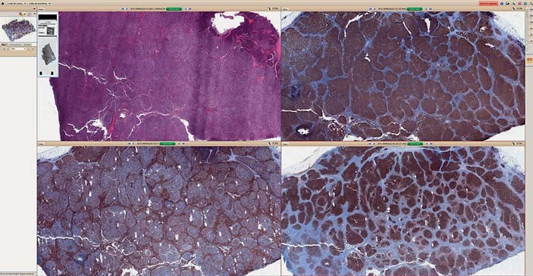Fig. 3. The viewer allows displaying simultaneously several slides on the screen, thus facilitating the analysis and interpretation of immunohistochemical techniques.
[23] .
Using WSI, cases with very scant material and consultation cases can be investigated, even when the material has to be returned to the referral center. WSI enables immediate accessibility to old cases, without the need for technical staff to retrieve the slides or paraffin blocks from the archive. WSI also allows using cytological images while preserving the original slide [22] . Finally, WSI permits introducing FISH or immunofluorescence slides, which previously had to be shown on static images because of the deterioration and loss of fluorescence.

Weaknesses of WSI
T he main disadvantage of WSI is the initial economic investment for the acquisition of the scanner and the complete WSI system [1, 12] . The high-resolution WSI images are associated with files of very large size, which means significant needs in terms of disk memory for their storage. Thus, high-capacity servers to store and distribute the information are needed, and regular maintenance of the servers is required. Proper functioning of the system requires high-speed Internet connection [4] .
However, the tool can be used for different subjects and, thus, be shared by different departments at the school (histology, pathology or medical specialties). A possible solution to this problem is the use of scanners already working at the institution for pathological diagnosis and using free or low-cost software to view the virtual slides [1] . Several vendors offer renting systems that include the digitalization of a set (or a few sets) of slides, the use of teaching software and a number of terabytes in a server. This option eliminates the investment in the equipment and reduces the costs associated with servers. In any case, computer classrooms are much more versatile than laboratories of microscopy, and all the initial economic disadvantages of WSI are rewarded with time, because the investment in computer equipment and maintenance is much less than that of the costs associated with a laboratory with optical microscopes [9, 15] .
Another possible disadvantage is that in the centers that only use WSI, the students do not learn how to use a conventional light microscope. Nonetheless, this is a minor problem since most medical students almost never use the microscope after finishing their training. Indeed, it is more important for them to recognize histological patterns and lesions than to learn how to use the tool [8, 15, 24] .
Finally, the use of these computer-based tools may result in a dramatic reduction in the personal contact between teachers and students. Actions promoting face-toface meetings should be considered to avoid the depersonalization associated with the spread in the use of computers. On the other hand, periodic quality control of WSI is highly recommended. This should include a comparison between virtual and glass slides, an evaluation of the use of the system outside the course schedule and the registration of what virtual images and which areas in these virtual images are most often seen by the students [1] .
Pathobiology 2016;83:79–88
DOI: 10.1159/000442391

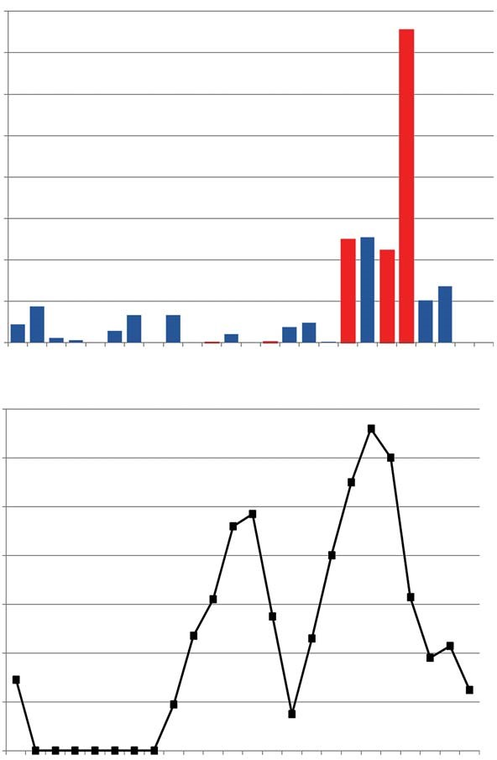
WSI in Undergraduate Teaching
Fig. 4. a Number of accesses to the virtual slides from the opening of the website to the day of the examination. The x-axis shows the day slides were accessed in relation to the examination (day 0). The y-axis shows the absolute number of accesses. Red columns identify accesses on weekends/holidays (Saturday, Sunday or other holidays). Blue columns indicate workdays. b Time virtual slides were accessed during the day. The x-axis shows the time of the day and the y-axis shows the absolute number of accesses.
400
350
300
250
200
150
100
50
0
Accesses (n)
140
120
100
80
60
40
20
0
0 1 2 3 4 5 6 7 8 9 1011121314151617181920212223
Accesses (n)
–30–28
–19–15–13–11–9–7–5–3–1Exam
Day
Time of day (h)
a
b
T he number of centers using WSI in undergraduate teaching, either as a complement to or as a substitute of CLM, has markedly increased over the last few years. Many studies have shown excellent results with WSI, not only for medical students but also for students of biology, dentistry, parasitology and veterinary medicine [2, 7, 8, 23, 25–30]. Many of these centers have evaluated the opinion of students after the introduction of WSI, and all have reported very positive feedback [9, 26, 30, 31] . One of the most valued advantages is the improved accessibility to the slides with WSI, allowing the student to access the slides at any time and from any place [10, 14, 19] . Several studies have shown that this is one of the most appreciated features of WSI, and this was the most prized feature in a study conducted at our institution [10] . Indeed, data obtained from the audit of accesses to the navigator at our institution showed that over half of the accesses are made on holidays and over one third after working hours (f ig. 4 ).
Students consider the use of WSI to be easier than that of CLM. WSI allows them to concentrate on the tissues and lesions and not on handling the microscope [8, 15, 32] . All studies agree that WSI improves collaboration between students and self-learning [6, 9, 16, 24, 33, 34] . Teachers also positively evaluate WSI because, although there is initially a significant increase in the time related to the preparation of the material, in the end it results in a significant reduction in the time spent in the preparation of the lessons [19, 35]. WSI provides a more complete approach to the cases by adding clinical information, radiological imaging, macroscopic images, immunohistochemical stains and molecular data to the virtual histological images [33, 36] . This can more accurately simulate the actual diagnostic practice and seems to be associated with better final results. Most studies agree that the image quality is better with WSI than with CLM, because the microscopes used for undergraduate teaching are, in general, of poor quality [20]. Images generated at a ×200 magnification are of sufficient quality for undergraduate teaching.
The negative evaluations are basically related to technical aspects, such as the speed in loading the images or compatibility problems with some computer models. A high-speed Internet connection and a server with sufficient capacity are required, especially when many students view slides at the same time [12] . Some centers have solved the problem of storage space by giving the virtual images on a DVD support or scanning only the portion of tissue they want to view, thus saving space in relation with the whole slide [37] . There is still some controversy about whether WSI can totally replace CLM, because students using WSI do not learn how to handle the CLM. The students’ opinions about this issue are divided. Most studies reveal that the teachers think that it is more important for the students to use their time in learning histology or pathology than in getting familiar with the technical aspects of the management of the microscope [2] .
Finally, the evaluation process using WSI offers choosing between numerous slides and allows the homogenization of the test, because all the students can visualize the same slide. In addition, in contrast to CLM, only the histopathological knowledge of the student is evaluated using WSI, obviating the influence of the students’ ability to manage the microscope [32] . Students positively evaluate the use of WSI in the tests as long as the practices are carried out in the same way [30]. Indeed, it is strongly recommended that the same system be used to perform the practical lessons and the examinations. There is major reluctance to completely abandon CLM when lessons are taken with WSI and the tests are performed with glass slides. In contrast, if WSI is also used for the evaluation, the students do not feel the need to use CLM during the course [30]. Comparing the final results of students using WSI with those using CLM (either in the same year or in previous years), either no differences have been observed or results were better among those using WSI. Moreover, students using WSI seem to recognize histological patterns better [5, 31, 38, 39] .
In summary, studies assessing the use of WSI by students have shown very positive results. WSI does not seem to affect the final knowledge or may even improve it [10, 40–42] .

WSI in Postgraduate Training (Residency and Fellowship Programs)
O ne of the first uses of WSI was to create series of interesting cases for residents or fellows in pathology and other specialties that require histological recognition of normal and pathological tissues [17] . Preparing virtual slides prevents the loss of biopsy material in making sections for teaching, thus making a collection of interesting cases much easier. Many residents can view the same image at the same time, with the possibility of working outside the center facilities and at any hour. These features provide an optimization of time and generate more comfort for residents and fellows.
The presence of annotations on the virtual slides also represents a major improvement because it facilitates learning. In a study comparing results between residents of dermatology and pathology who visualized the same virtual images supplemented with or without annotations made by teachers, residents whose preparations had annotations showed a better score, because the learning was more directed towards the most characteristic histological changes that led to the correct diagnosis [21] .
WSI has also successfully been used to measure the learning level reached by residents. Several initiatives, such as the European Association of Pathology Chairs and Residency Program Directors, aim to homogenize the knowledge of residents all over Europe evaluating them by performing a test containing virtual slides [17] . WSI is well evaluated by residents in the studies, although the final results comparing abilities reached with WSI and CLM differ from one study to another [43–45] . The
Pathobiology 2016;83:79–88
DOI: 10.1159/000442391
presence of clinical and radiological information and previous practice using WSI seem to influence the results
[36] .
Some studies point out the relevance of establishing the steps involved in the diagnostic process, stressing that residents should learn not only what the correct diagnosis is, but also what the logical sequence to achieve this diagnosis is. These studies use eye-tracking cameras that pick up eye movement during the diagnostic process. The difference between senior pathologists and residents are established by examining which fields are more often viewed, the time spent in these fields and the order in which the slide is observed. Residents spend much more time evaluating the slides than experienced pathologists. However, experienced pathologists are slower in choosing the field in where they will zoom and they do this more frequently in areas outside central (foveal) vision than residents. Thus, there are two kinds of slide evaluation: one more dispersed and time-consuming and another more targeted and effective [17, 46] .
Although WSI is currently mainly a complement to CLM, in the future it is expected to almost completely replace CLM as the use of WSI in routine diagnosis expands in laboratories of pathology. Studies to determine the impact of training pathologists without exposure to actual glass slides are warranted.

WSI in Schools of Cytopathology
The homogeneity in the quality of the images displayed to the students is a highly appreciated feature of WSI and represents a major advantage in cytopathology, because it allows many students to use the same slide simultaneously without the risk of breaking or losing the slide. In addition, annotated digitized slides are very useful for teaching cytomorphology to cytotechnologists. The use of annotations for evaluation has excellent results, allowing comparison between expert cytologists and students [47] .
However, the implications of the relatively low resolution of some WSI systems at low (screening) magnification still need to be solved. Moreover, viewing through a CLM may provide a different perceived field width than what is seen on a monitor. WSI has more difficulty in generating appropriate images due to the difficulties in focusing the images at different levels [48] . This problem can be solved with the use of software packages that allow focusing the different levels of the virtual slide thereby more closely simulating the daily practice of cytology.
In conclusion, although WSI has significant educational advantages, a number of technical problems should be solved before it can be confidently used to teach cytology.

Tumor Boards
Many hospitals have tumor boards where clinicians meet for multidisciplinary case presentations. Pathologists are often required to present the pathology findings at the board presentations. WSI is currently successfully used for this purpose at several institutional tumor boards [49 , 50]. The use of WSI in tumor boards and interdisciplinary sessions also helps to bring histology knowledge to residents of medical or surgical specialties who do not have much contact with the laboratory [22] .

Tele-Education and e-Learning
The use of e-learning and tele-education is expanding extraordinarily because it allows providing continuous medical education in a practical and convenient way, markedly reducing costs. Virtual workshops avoid the need to travel to meetings, providing significant economic savings and more flexibility. WSI allows easy visualization of the cases and eliminates the requirement of sending the glass slides, saving time and the costs of courier service. Moreover, the system avoids the risks of loss of or damage to the glass slides [22] . Different online services permit the access to online teaching with the objective of sharing virtual slides (e.g. PathXchange, vMic Pathorama or Slide2Go) [51] .
The use of this technology is markedly spreading, and numerous institutions promote web-based learning. The United States and Canadian Academy of Pathology (USCAP), the American Society of Cytopathology and the International Academy of Cytopathology, among others, have virtual atlases that include numerous cases with educational purposes [52]. Currently, there are several collections of cases aimed at teaching residents such as the Dr. Juan Rosai collection (www.rosaicollection. org; approx. 20,000 cases from 1945 onwards), the collection of the Pathological Society of Great Britain (www.pathsoc.org) or other collections intended for the general public (www.virtualpathology.leeds.ac.uk) [17, 22, 53]. Virtual slides and seminars are offered by the USCAP online academy (>100 virtual slides from different organ systems). The number of journals that allow

access to WSI examples to illustrate the articles, thus the ability to display the same slide anywhere and at any improving the content of the publication, is also on the time by several people simultaneously makes this techrise. nology much more convenient than CLM. However, the high maintenance costs of the laboratories of microscopy and optimization of the time of teachers and students
Perspectives for the Future with the use of WSI is likely to push most training centers towards the replacement of CLM by WSI. WSI is also ex-
CLM has been used in pathology departments, as well traordinarily expanding as a tool for tele-education and as in the laboratories of the schools of medicine, biology, e-learning. Further investigation is necessary to improve dentistry and veterinary medicine, for decades. Its re- the existing WSI applications specifically designed for edplacement by new technologies represents a major chal- ucation and to develop ergonomic tools that improve the lenge. However, increasing needs of education and grow- navigation of virtual slides. It is possible that in the near ing evidence indicating the very positive effect of WSI on future textbooks will have the option to visualize WSI, teaching undergraduates and pathologists are resulting in which will be facilitated with the use of portable devices a significant expansion of this tool. Comfort in its use and like tablets or smartphones [22] .

References
- Paulsen FP, Eichhorn M, Brauer L: Virtual microscopy – the future of teaching histology in the medical curriculum? Ann Anat 2010; 192: 378–382.
- Blake CA, Lavoie HA, Millette CF: Teaching medical histology at the University of South Carolina School of Medicine: transition to virtual slides and virtual microscopes. Anat Rec B New Anat 2003; 275: 196–206.
- Pantanowitz L, Valenstein PN, Evans AJ,
Kaplan KJ, Pfeifer JD, Wilbur DC, Collins LC, Colgan TJ: Review of the current state of whole slide imaging in pathology. J Pathol Inform 2011; 2: 36.
- Al-Janabi S, Huisman A, Van Diest PJ: Digital pathology: current status and future perspectives. Histopathology 2012; 61: 1–9.
- Anyanwu GE, Agu AU, Anyaehie UB: Enhancing learning objectives by use of simple virtual microscopic slides in cellular physiology and histology: impact and attitudes. Adv Physiol Educ 2012; 36: 158–163.
- Husmann PR, O’Loughlin VD, Braun MW:
Quantitative and qualitative changes in teaching histology by means of virtual microscopy in an introductory course in human anatomy. Anat Sci Educ 2009; 2: 218–226.
- Farah CS, Maybury TS: The e-evolution of microscopy in dental education. J Dent Educ 2009; 73: 942–949.
- Fonseca FP, Santos-Silva AR, Lopes MA, Almeida OP, Vargas PA: Transition from glass to digital slide microscopy in the teaching of oral pathology in a Brazilian dental school. Med Oral Patol Oral Cir Bucal 2015; 20:e17– e22.
- Boutonnat J, Paulin C, Faure C, Colle PE, Ronot X, Seigneurin D: A pilot study in two French medical schools for teaching histology using virtual microscopy. Morphologie 2006;
90: 21–25.

- Ordi O, Bombi JA, Martinez A, Ramirez J,
Alos L, Saco A, Ribalta T, Fernandez PL, Campo E, Ordi J: Virtual microscopy in the undergraduate teaching of pathology. J Pathol Inform 2015; 6: 1.
- Romer DJ, Suster S: Use of virtual microscopy for didactic live-audience presentation in anatomic pathology. Ann Diagn Pathol 2003; 7: 67–72.
1 2 Foster K: Medical education in the digital age: digital whole slide imaging as an e-learning tool. J Pathol Inform 2010; 1: 14.
- Harris T, Leaven T, Heidger P, Kreiter C, Duncan J, Dick F: Comparison of a virtual microscope laboratory to a regular microscope laboratory for teaching histology. Anat Rec 2001; 265: 10–14.
- Merk M, Knuechel R, Perez-Bouza A: Web-based virtual microscopy at the RWTH Aachen University: didactic concept, methods and analysis of acceptance by the students. Ann Anat 2010; 192: 383–387.
- Braun MW, Kearns KD: Improved learning efficiency and increased student collaboration through use of virtual microscopy in the teaching of human pathology. Anat Sci Educ
2008; 1: 240–246.
1 6 Craig FE, McGee JB, Mahoney JF, Roth CG: The Virtual Pathology Instructor: a medical student teaching tool developed using patient simulator software. Hum Pathol 2014; 45:
1985–1994.
1 7 Hamilton PW, Wang Y, McCullough SJ: Virtual microscopy and digital pathology in training and education. APMIS 2012; 120: 305–315.
1 8 Collier L, Dunham S, Braun MW, O’Loughlin VD: Optical versus virtual: teaching assistant perceptions of the use of virtual microscopy in an undergraduate human anatomy course. Anat Sci Educ 2012; 5: 10–19.
- 9 Szymas J, Lundin M: Five years of experience teaching pathology to dental students using the WebMicroscope. Diagn Pathol 2011;
6(suppl 1):S13.
- 0 Helin H, Lundin M, Lundin J, Martikainen P,
Tammela T, Helin H, van der Kwast T, Isola J: Web-based virtual microscopy in teaching and standardizing Gleason grading. Hum
Pathol 2005; 36: 381–386.
21 Marsch AF, Espiritu B, Groth J, Hutchens KA: The effectiveness of annotated (vs. non-annotated) digital pathology slides as a teaching tool during dermatology and pathology residencies. J Cutan Pathol 2014; 41: 513–518.
2 2 Pantanowitz L, Szymas J, Yagi Y, Wilbur D: Whole slide imaging for educational purposes. J Pathol Inform 2012; 3: 46.
23 Linder E, Lundin M, Thors C, Lebbad M, Winiecka-Krusnell J, Helin H, Leiva B, Isola J, Lundin J: Web-based virtual microscopy for parasitology: a novel tool for education and quality assurance. PLoS Negl Trop Dis 2008; 2:e315.
2 4 Kumar RK, Velan GM, Korell SO, Kandara M, Dee FR, Wakefield D: Virtual microscopy for learning and assessment in pathology. J Pathol 2004; 204: 613–618.
2 5 Chen YK, Hsue SS, Lin DC, Wang WC, Chen JY, Lin CC, Lin LM: An application of virtual microscopy in the teaching of an oral and maxillofacial pathology laboratory course. Oral Surg Oral Med Oral Pathol Oral Radiol Endod 2008; 105: 342–347.
26 Diaz-Perez JA, Raju S, Echeverri JH: Evaluation of a teaching strategy based on integration of clinical subjects, virtual autopsy, pathology museum, and digital microscopy for medical students. J Pathol Inform 2014; 5: 25.
Pathobiology 2016;83:79–88 DOI: 10.1159/000442391
2 7 Gatumu MK, MacMillan FM, Langton PD, Headley PM, Harris JR: Evaluation of usage of virtual microscopy for the study of histology in the medical, dental, and veterinary undergraduate programs of a UK University. Anat Sci Educ 2014; 7: 389–398.
2 8 Helle L, Nivala M, Kronqvist P, Gegenfurtner A, Bjork P, Saljo R: Traditional microscopy instruction versus process-oriented virtual microscopy instruction: a naturalistic experiment with control group. Diagn Pathol 2011; 6(suppl 1):S8.
- McCready ZR, Jham BC: Dental students’ perceptions of the use of digital microscopy as part of an oral pathology curriculum. J Dent Educ 2013; 77: 1624–1628.
- Weaker FJ, Herbert DC: Transition of a dental histology course from light to virtual microscopy. J Dent Educ 2009; 73: 1213–1221.
- Krippendorf BB, Lough J: Complete and rap-id switch from light microscopy to virtual microscopy for teaching medical histology. Anat Rec B New Anat 2005; 285: 19–25.
3 2 Kumar RK, Freeman B, Velan GM, De Permentier PJ: Integrating histology and histopathology teaching in practical classes using virtual slides. Anat Rec B New Anat 2006; 289: 128–133.
33 Durosaro O, Lachman N, Pawlina W: Use of knowledge-sharing web-based portal in gross and microscopic anatomy. Ann Acad Med
Singapore 2008; 37: 998–1001.
3 4 Goldberg HR, Dintzis R: The positive impact of team-based virtual microscopy on student learning in physiology and histology. Adv Physiol Educ 2007; 31: 261–265.
- Triola MM, Holloway WJ: Enhanced virtual microscopy for collaborative education. BMC Med Educ 2011; 11: 4.
- Bruch LA, De Young BR, Kreiter CD, Haugen TH, Leaven TC, Dee FR: Competency assessment of residents in surgical pathology using virtual microscopy. Hum Pathol 2009; 40: 1122–1128.
- Gongora JH, Barcelo HA: Telepathology and continuous education: important tools for pathologists of developing countries. Diagn Pathol 2008; 3(suppl 1):S24.
- Scoville SA, Buskirk TD: Traditional and vir-tual microscopy compared experimentally in a classroom setting. Clin Anat 2007; 20: 565–570.
3 9 Sivamalai S, Murthy SV, Gupta TS, Woolley T: Teaching pathology via online digital microscopy: positive learning outcomes for rurally based medical students. Aust J Rural Health 2011; 19: 45–51.
- Inuwa IM, Taranikanti V, Al-Rawahy M, Habbal O: Anatomy practical examinations: how does student performance on computerized evaluation compare with the traditional format? Anat Sci Educ 2012; 5: 27–32.
- Mione S, Valcke M, Cornelissen M: Evalua-tion of virtual microscopy in medical histology teaching. Anat Sci Educ 2013; 6: 307–315.
4 2 Tian Y, Xiao W, Li C, Liu Y, Qin M, Wu Y, Xiao L, Li H: Virtual microscopy system at Chinese medical university: an assisted teaching platform for promoting active learning and problem-solving skills. BMC Med Educ 2014; 14: 74.
4 3 Brick KE, Sluzevich JC, Cappel MA, DiCaudo DJ, Comfere NI, Wieland CN: Comparison of virtual microscopy and glass slide microscopy among dermatology residents during a simulated in-training examination. J Cutan Pathol 2013; 40: 807–811.
44 Brick KE, Comfere NI, Broeren MD, Gibson LE, Wieland CN: The application of virtual microscopy in a dermatopathology educational setting: assessment of attitudes among dermatopathologists. Int J Dermatol 2014; 53: 224–227.
4 5 Koch LH, Lampros JN, Delong LK, Chen SC, Woosley JT, Hood AF: Randomized comparison of virtual microscopy and traditional glass microscopy in diagnostic accuracy among dermatology and pathology residents.
Hum Pathol 2009; 40: 662–667.
4 6 Krupinski EA, Tillack AA, Richter L, Henderson JT, Bhattacharyya AK, Scott KM, Graham AR, Descour MR, Davis JR, Weinstein RS: Eyemovement study and human performance using telepathology virtual slides: implications for medical education and differences with experience. Hum Pathol 2006; 37: 1543–1556.
47 Stewart J III, Bevans-Wilkins K, Bhattacharya A, Ye C, Miyazaki K, Kurtycz DF: Virtual microscopy: an educator’s tool for the enhancement of cytotechnology students’ locator skills. Diagn Cytopathol 2008; 36: 363–368.
4 8 Donnelly AD, Mukherjee MS, Lyden ER, Radio SJ: Virtual microscopy in cytotechnology education: application of knowledge from virtual to glass. Cytojournal 2012; 9: 12.
4 9 Heffner S: Streamlining tumor board reviews. Adv Lab 2008; 17: 20.
50 Spinosa J: Scripp’s tumor board finds value in digital imaging of slides. Dark Rep 2009; 12: 10–15.
5 1 Conran R, Fontelo P, Liu F, Fontelo M, White E: Slide2Go: a virtual slide collection for pathology education. AMIA Annu Symp Proc 2007, p 918.
- Khalbuss WE, Pantanowitz L, Parwani AV: Digital imaging in cytopathology. Patholog Res Int 2011; 2011: 264683.
- Rosai J: Digital images of case reports and oth-er articles. Int J Surg Pathol 2007; 15: 5.

